- Quy mô phổ thông (vua va nhỏ) :

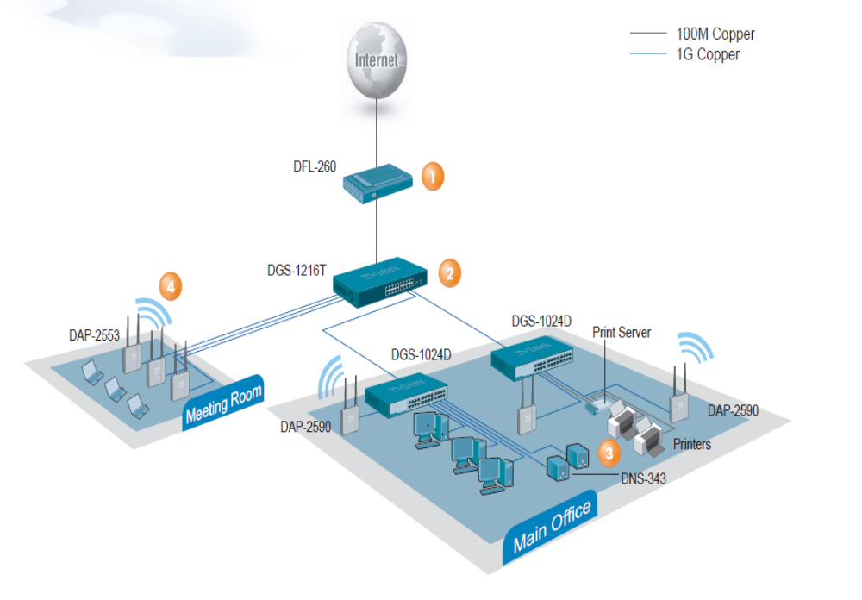

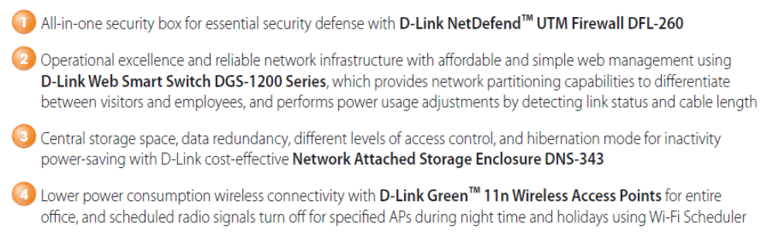
DFL-260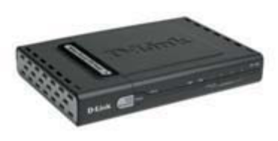(1294USD)
10/100BASE-TX x 6
(WAN x 1 / DMZ x 1 / LAN x 4)
• Anti-Virus
• Stateful Packet Inspection
• Intrusion Detection Prevention (IDP)
• PPPoE
• IPSec/PPTP/L2TP VPN
• Bandwidth Management
• URL Filtering
• P2P Blocking
• WAN Failover
• Transparent Mode
• Web Content Filtering
• Anti-Spam

DGS-1216T 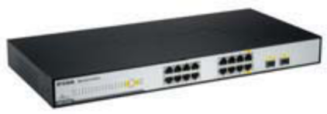(400USD)

10/100/1000BASE-T x 14
1000BASE-T/SFP Combo Slot x 2
• SNMP
• VLAN
• QoS
• 802.1X Authentication

DGS-1024D 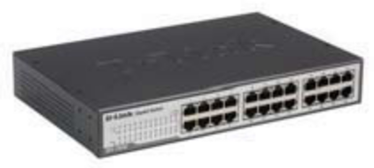(317USD)

10/100/1000BASE-T x 24
• Flow Control
• QoS
• Jumbo Frame
• Cable Diagnostic

DAP-2590 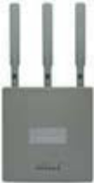 (520USD)
10/100/1000BASE-T x 1
(PoE Enabled)
• 802.11n Dualband (draft)
• 802.11a/b/g
• WPA2
• Wireless Distribution System
• MAC Filtering
• 802.1Q VLAN
• Rogue AP Detection
• Multiple SSID
• Plenum-Rated Chassis

DAP-2553 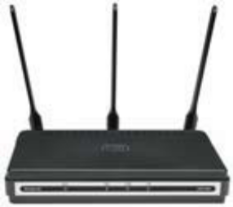 (273USD)
10/100/1000BASE-T x 1
(PoE Enabled)
• 802.11n Dualband (draft)
• 802.11a/b/g
• WPA2
• Wireless Distribution System
• MAC Filtering
• 802.1Q VLAN
• Rogue AP Detection
• Multiple SSID

DNS-343 4-Bay Network Storage Enclosure (579USD)
• Easily Insert up to 4 SATA Hard Drives¹ Without Using Tools
• Protect Important Files Using RAID 1 or RAID 5 Technology
• Access Stored Files Over the Internet
• OLED Display Screen

- Giải pháp cho khách sạn :

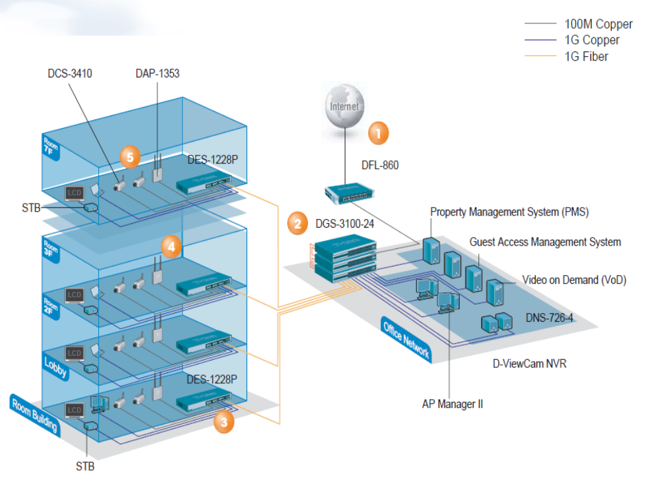

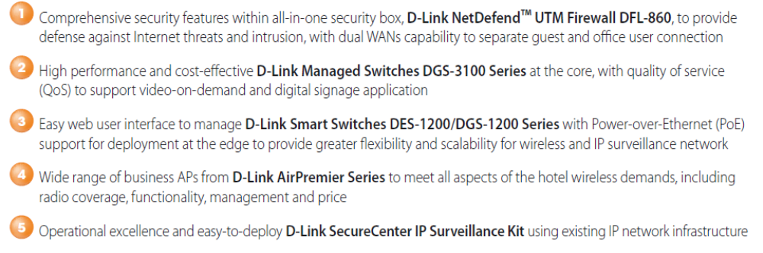
DFL-860 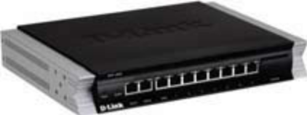 (2000USD)

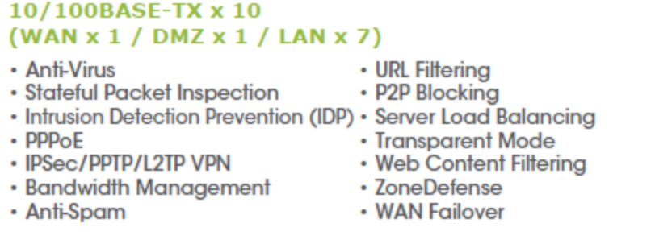
DGS-3100-24 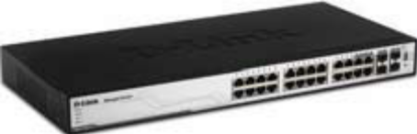 (1000USD)
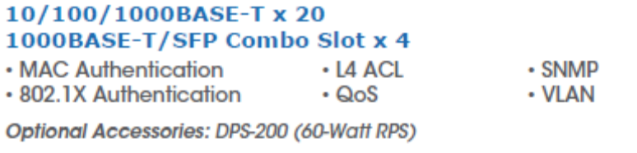

DES-1228P 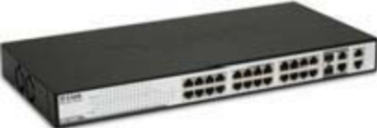 (580USD)
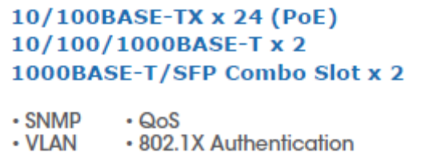

DAP-1353 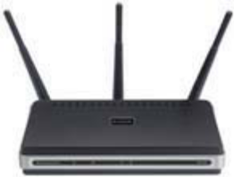
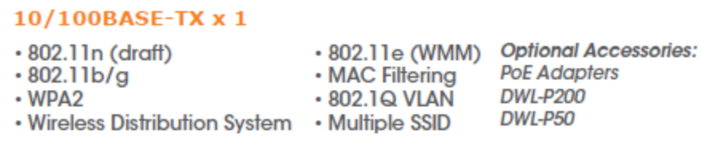
DCS-3410 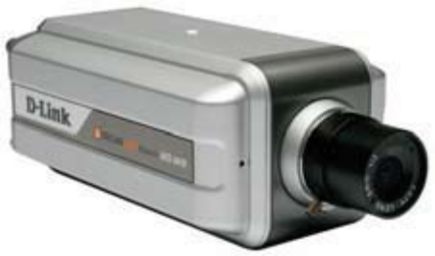 (600USD)
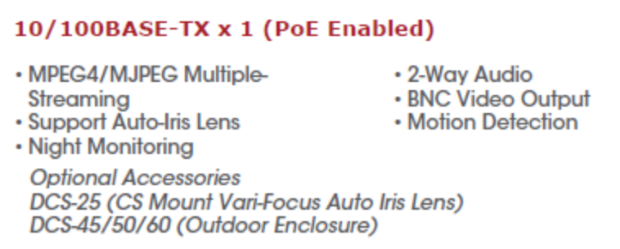

DNS-726-4 (1100USD)

Features
- Reliable Network Camera Surveillance Recorder for Home and Business
- View Real-Time Video of All 4 Cameras from Anywhere in Your Home or Office, or Remotely via the Internet
- Effortless Network Camera Setup and Management
- "Smart Search" Technology Accelerates and Simplifies Event Investigation
- D-Link Green Solution: Consumes Less Power and Eliminates the Need for a Dedicated PC for Continuous Recording
- Precision Playback with Step/ Fast forward/Rewind and Video Enhancement

- Quy mô lớn (Enterprise):

